INTRODUCTION TO MATLAB

(MTH3006)

ASSIGNMENT SET – 05

Structures and Function Handles

Submission Date : 4th April 2018

Branch: E.E.E |  | Section: A
Name | Registration No. | Signature
UMASHANKAR PATI | 1641014158

Department of Electrical and Electronics Engineering

Institute of Technical Education and Research
(Faculty of Engineering)

Siksha ‘O’ Anusandhan Deemed to be University Bhubaneswar
1. Assignment Question 01

Write a MATLAB function that will accept a cell array of strings and sort them into ascending order according to alphabetical order. (This implies that you must treat ‘A’ and ‘a’ as the same letter.)

Solution

Clearly state the problem that you are trying to solve.

%SCRIPT FILE:assign5Q1
%PURPOSE: To accept a cell array and sort them alphabetically.
%
% RECORD OF REVISION:
% Date Programmer Registration Number Description of Change
% ====== ============ =================== ====================
% 26/03/2018 Umashankar Pati 1641014158 Original Code

Define the inputs required by the program and the outputs to be produced by the program.

INPUT:-n,name
OUTPUT-[CN,KK],CN
Design the algorithm that you intend to implement in the program.

%1.Create a function mysort
%2.input the names in an array in the main file
%3.store the array of sorted names in the main file.

Turn the algorithm into MATLAB statements.

function [cn,kk]=sortcellstring(c)
zz=length(c);
for j=1:zz
l(j)=length(c{1,j});
end
kk=min(l);
for i=1:zz
for t=1:kk
zc{1,i}(t)=lower(c{1,i}(t));
z(i,t)=double(zc{1,i}(t));
end
end
[pp,kk]=sortrows(z);
cn=c(1,kk);
end

clc;
clear all;
close all;
n=input(‘enter the number of names that you want:’);
for k=1:n
name{1,k}=input(‘enter the name’);
end
[cn,kk]=sortcellstring(name);
Cn
Test the resulting MATLAB program.

'amit' 'khalid' 'subham' 'uma’
2. Assignment Question 02

Write a function called June2015 that returns a cell array of dimensions 30-by-3, whose rows correspond to the days of June, 2015. The three elements of each row must be set as follows:

- The first element refers to the string 'June' (uppercase ‘J’).

- The second element refers to a scalar of type double that equals the date (1 through 30).

- The third element refers to the three-letter abbreviation of the day chosen from this list: 'Mon', 'Tue', 'Wed', 'Thu', 'Fri', 'Sat', 'Sun'.

For example, here is a call of the function followed by a command that shows the eleventh element of the cell array that is returned by the function:

>> m = June2015; >> m(11,:)

ans = 'June' [11] 'Thu'

Solution

Clearly state the problem that you are trying to solve.

%SCRIPT FILE:assign5Q2
%PURPOSE: To call June2015 that returns a cell array of dimensions 30 *3, whose row respond to the days of june 2015.
%
% RECORD OF REVISION:
% Date Programmer Registration Number Description of Change
% ====== ============ =================== ====================
% 26/03/2018 Umashankar Pati 1641014158 Original Code

Define the inputs required by the program and the outputs to be produced by the program.

INPUT:-M,k,n
Output-m
Design the algorithm that you intend to implement in the program.

1.Creat a function file having sortcellstring.m as its name having output as values.
2.In the mainfile,enter the number of names and names that you want to be sorted
3.Call the function to get the output in the main file.
4.Display the output date.
5.end

Turn the algorithm into MATLAB statements.

function m=june2015()
n=30;
k=3;
ch={'sun', 'mon', 'tue', 'wed', 'thr', 'fri', 'sat'};
for i=1:n
m{i,1}='June';
m{i,2}=i;
end
d=7;
kk=round(n/7);
ll=mod(n,7);
for i=1:d
m{i,3}=ch{1,i};
end
j=1;
for i=d+1:(kk-2)*d
m{i,3}=ch{1,j};
j=j+1;
end

j=1;
for i=(kk-2)*d+1:(kk-1)*d
m{i,3}=ch{1,j};
j=j+1;
end

j=1;
for i=(kk-1)*d+1:kk*d
m{i,3}=ch{1,j};
j=j+1;
end
m{n-1,3}='sun';
m{n,3}='mon';
end

clc;
clear all;
close all;
m=june2015;
m(16,:)

Test the resulting MATLAB program.

ans=
‘june’ [16] ‘mon’
3. Assignment Question 03

Define a structure point containing three fields x, y and z. The x field will contain the x-position of the point, the y field will contain the y-position of the point and the z field will contain the z-position of the point. Then write a function dist3D that accepts two points A and B and returns the Euclidian distance between the two points on the Cartesian plane. Be sure to check the number of input arguments in your function. Fill up the following table using your program.

A | B | Distance
(3, 1 , 5) | (1, -5 , 2)
(-8, 1 , -2) | (3, 7 , -9)
(4, 1 , -3) | (-2, 5, 4)

Solution

Clearly state the problem that you are trying to solve.

%SCRIPT FILE:assign5Ques3Uma.m
%PURPOSE: To calculate the Euclidian distance between two points on a Cartesian plane
%
% RECORD OF REVISION:
% Date Programmer Registration Number Description of Change
% ====== ============ =================== ====================
% 28/03/2018 Umashankar Pati 1641014158 Original Code

Define the inputs required by the program and the outputs to be produced by the program.

INPUT:A,B
OUTPUT:table(A,B,distance)

Design the algorithm that you intend to implement in the program.

%1-a function dist3D was created
%2-euclidian distance was calculated using the formula
%3-in the main function the points were stored
%4-the structure array was created and the the dust3D function was called.

Turn the algorithm into MATLAB statements.

function d=dist3D(A, B)
d=sqrt((A(1)-B(1))^2+(A(2)-B(2))^2+(A(3)-B(3))^2);
end

clc;
clear;
close;
A=[3 1 5;-8 1 -2;4 1 -3];
B=[1 -5 2; 3 7 -9; -2 5 4];
l=size(A,1);
for i=1:l
struct.x(i,:)=A(i,:);
struct.y(i,:)=B(i,:);
d(i)=dist3D(struct.x(i,:), struct.y(i,:));
c{i,1}=mat2str(struct.x(i,:));
c{i,2}=mat2str(struct.y(i,:));
c{i,3}=mat2str(d(i));
end
t=cell2table(c);
t.Properties.VariableNames={'Point_A' 'Point_B' 'Distance'}

Test the resulting MATLAB program.

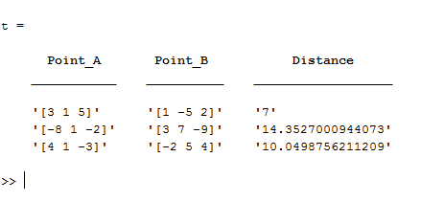

ans=

A B distance

‘3 1 5’ ‘1 -5 2’ 7

‘8 1 -2’ ‘3 7 -9’ 14.353

‘4 1 -3’ ‘-2 5 4’ 10.05

4. Assignment Question 04

Create a structure array containing all of the information needed to plot a data set. At a minimum, the structure array should have the following fields:
- x_data :x-data (one or more data sets in separate cells)
- y_data :y-data (one or more data sets in separate cells)
- type : linear, semilogx, and so forth
- plot_title :plot title

- x_label :x-axis label
- y_label: y-axis label
You may add additional fields that would enhance your control of the final plot..After this structure array has been created, create a MATLAB function that accepts an array of this structure and produces one plot for each structure in the array. The function should apply intelligent defaults if some data fields are missing. For example, if the plot_title field is an empty matrix, then the function should not place a title on the graph. Think carefully about the proper defaults before starting to write your function! .To test your function, create a structure array containing the data for three plots of three different types and pass that structure array to your function. The function should correctly plot all three data sets in three different figure windows.

Solution

Clearly state the problem that you are trying to solve.

%SCRIPT FILE:assign5Ques4Uma.m
%PURPOSE: To create a structure array and to plot the set of data
%
% RECORD OF REVISION:
% Date Programmer Registration Number Description of Change
% ====== ============ =================== ====================
% 9/04/2018 Umashankar Pati 1641014158 Original Code

Define the inputs required by the program and the outputs to be produced by the program.

INPUT: xdata,a
OUTPUT: plot

Design the algorithm that you intend to implement in the program.

%1-The function plot_stru was created
%2-The type of plot to be done was declared inside it
%3-In the main file the values of xdata, ydata1, ydata2, ydata3 were given
%4-During plot care was taken so as if the data fields were missing then it should not place the title on the graph.

Turn the algorithm into MATLAB statements.

Clc;
Clear all;
Close all;
a(1).x_data=0:0.01:2*pi;
a(1).y_data=sin(a(1).x_data);
a(1).type=’linear’;
a(1).title=’sin plot’;
a(1).x_label=’time’
a(1).y_lable=’sin(x)’;
a(2).x_data=0:100;
a(2).y_data=log(a(2).x_data);
a(2).type=’linear’;
a(2).title=’log plot’;
a(2).x_lable=’time’;
a(2).y_lable=’log(x)’;
a(3).x_data=0:1:100;
a(3).y_data=exp(a(3).x_data);
a(3).type=’linear;
a(3).title =’exp plot’;
a(3).x_lable=’time’;
a(3).y_lable=’exp(x)’;
plot_struct(a)

function output=plot_struct(a)
figure(1);
plot(a(1).x_data,a(1).y_data);
title(a(1).title);
xlabel(a(1).x_label);
ylabel(a(1).y_label);
figure(2);
plot(a(2).x_data(2).y_data);
title(a(2).title);
xlabel(a(2).x_label);
ylablel(a(2).y_label);
figure(3);
plot(a(3).x_data,a(3).y_data);
title(a(3).title);
xlabel(a(3).x_label);
ylabel(a(3).y_label);
end

Test the resulting MATLAB program.

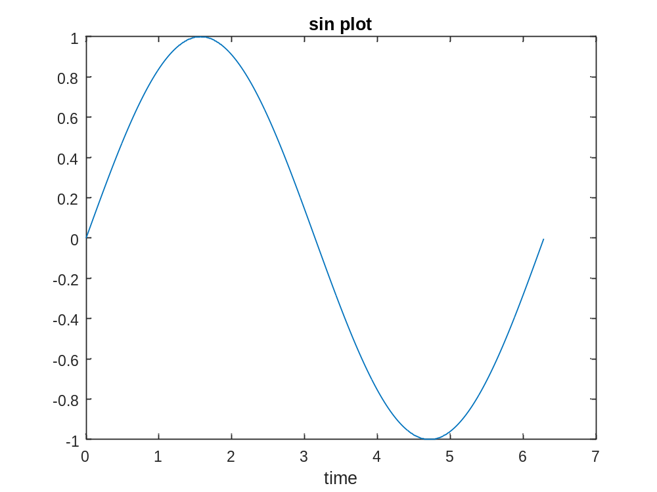

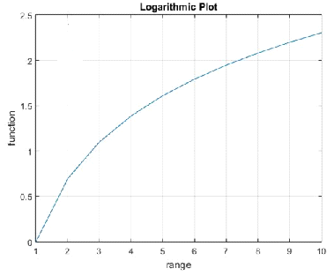

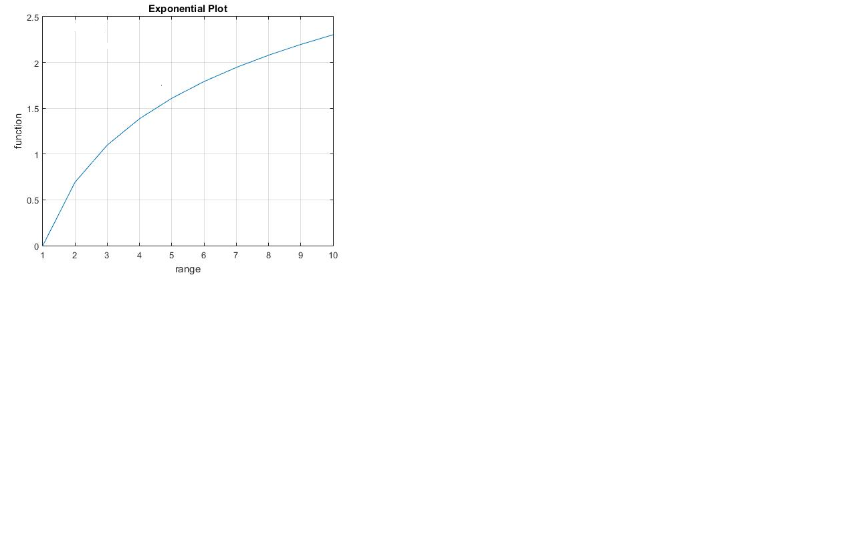

5. Assignment Question 05

Write a function that will accept a structure array of student as defined in this chapter, and calculate the final average of each one, assuming that all exams have equal weighting. Add a new field to each array to contain the final average for that student, and return the updated structure to the calling program. Also, calculate and return the final class average.

Solution

Clearly state the problem that you are trying to solve.

%SCRIPT FILE:assign5Q5
%PURPOSE: To create a structure array of student to calculate average and return final class average.
%
% RECORD OF REVISION:
% Date Programmer Registration Number Description of Change
% ====== ============ =================== ====================
% 9/04/2018 Umashankar Pati 1641014158 Original Code

Define the inputs required by the program and the outputs to be produced by the program.

INPUT:n,student

Design the algorithm that you intend to implement in the program.

% 1. Initialise c.
% 2. Start a loop to calculate the average of n student individually.
% 3. Add up the average marks.
% 4. Display the average class marks using ‘c’.
% 5. Prompt the user for the value of n.
% 6. Initialise the structure student.
% 7. Take input of marks of n students.
% 8. pass the structure in the function ‘av’.

Turn the algorithm into MATLAB statements.

function avg=average_value(asn1,asn2,asn3,asn4,asn5)
avg=(1/5)*(asn1+asn2+asn3+asn4+asn5)
end
clc;
clear all;
close all;
n=60;
student.a1=5*rand(1,n);
student.a2=3.7*rand(1,n);
student.a3=5*rand(1,n);
student.a4=4.25*rand(1,n);
student.a5=5*rand(1,n);
avg=average_value(student.a1,student.a2,student.a3,student.a4,student.a5)
student.average=avg;
for i=1:n
c{i,1}=i;
c{i,2}=mat2str(student.a1(i));
c{i,3}=mat2str(student.a2(i));
c{i,4}=mat2str(student.a3(i));
c{i,5}=mat2str(student.a4(i));
c{i,6}=mat2str(student.a5(i));
c{i,7}=mat2str(student.average(i));
end
t=cell2table(c);
t.Properties.VariableNames={'Slno' 'A1' 'A2' 'A3' 'A4' 'A5' 'Average' }

Test the resulting MATLAB program.

avg =

Columns 1 through 11

2.0278 2.5708 1.9400 2.3954 3.6215 2.5624 1.5697 2.1595 2.2283 2.4833 2.9642

Columns 12 through 22

3.2756 2.6765 1.5315 2.5021 1.4214 2.5479 2.5109 2.8604 3.1183 2.3544 2.4796

Columns 23 through 33

3.2363 3.1031 2.1561 2.1053 2.6233 2.2207 1.7866 2.0515 1.4628 1.0312 2.4669

Columns 34 through 44

2.5425 2.7119 2.4781 2.5364 2.0438 2.2205 0.9633 1.6340 2.8880 2.1032 2.2272

Columns 45 through 55

2.0798 2.5099 2.5729 3.0404 2.8194 2.2922 1.5328 1.5577 3.0447 1.4871 0.9532

Columns 56 through 60

1.5462 3.2381 2.7929 2.1519 1.9051

avg =

Columns 1 through 11

2.0278 2.5708 1.9400 2.3954 3.6215 2.5624 1.5697 2.1595 2.2283 2.4833 2.9642

Columns 12 through 22

3.2756 2.6765 1.5315 2.5021 1.4214 2.5479 2.5109 2.8604 3.1183 2.3544 2.4796

Columns 23 through 33

3.2363 3.1031 2.1561 2.1053 2.6233 2.2207 1.7866 2.0515 1.4628 1.0312 2.4669

Columns 34 through 44

2.5425 2.7119 2.4781 2.5364 2.0438 2.2205 0.9633 1.6340 2.8880 2.1032 2.2272

Columns 45 through 55

2.0798 2.5099 2.5729 3.0404 2.8194 2.2922 1.5328 1.5577 3.0447 1.4871 0.9532

Columns 56 through 60

1.5462 3.2381 2.7929 2.1519 1.9051

t =

Slno A1 A2 A3 A4 A5 Average
____ ___________________ ____________________ ____________________ ___________________ ___________________ ___________________

1 '4.07361843196589' '2.77968811943092' '0.533263850902922' '2.32478779221697' '0.42757898545022' '2.02778743599338'
2 '4.5289596853781' '0.943851927199296' '4.80949040427527' '1.25936342383304' '1.31241117349166' '2.57081532283547'
3 '0.63493408146753' '1.87204109116103' '0.0231711206703372' '3.16494443006516' '4.00507311384869' '1.94003276744255'
4 '4.5668792806951' '2.58658387382974' '3.87455232355751' '0.803058813888314' '0.146101387810731' '2.39543513595628'
5 '3.16179623112705' '3.29634203438245' '4.08651610326717' '2.91879559180259' '4.64427069739022' '3.6215441315939'
6 '0.487702024997048' '3.54937827326014' '4.34347352681755' '0.779922411883396' '3.65165431427726' '2.56242611024708'
7 '1.39249109433524' '2.02469746086607' '0.422179227554552' '1.56605953508393' '2.4430448690179' '1.56969443737154'
8 '2.73440759602492' '0.512910438466113' '1.99891324549448' '2.65887888310118' '2.89262530511719' '2.15954709364078'
9 '4.78753417717149' '0.552387820568513' '1.29935201425327' '3.31596659939335' '1.18641789885761' '2.22833170204885'
10 '4.82444267599638' '0.952780540257825' '4.00034240112154' '0.344784517679587' '2.29424414089966' '2.483318855191'
11 '0.788065408387741' '3.11065384713955' '2.15706913731772' '3.9498903766171' '4.81544269643457' '2.96422429317934'
12 '4.85296390880308' '0.940844062194665' '4.55323797214762' '3.29677888408571' '2.73402859369484' '3.27557068418518'
13 '4.78583474121473' '3.01285385645462' '0.909235141514262' '2.06886443771348' '2.60567915402001' '2.67649346618342'
14 '2.42687824361421' '0.90104238428246' '1.31901458260995' '1.85239900146891' '1.15797193354262' '1.53146122910363'
15 '4.001402344444' '3.43827540579274' '0.727694901923585' '1.89883093507668' '2.44448871960083' '2.50213846136757'
16 '0.709431693136077' '1.29493993414379' '0.680342793543319' '1.30198525607037' '3.12030044086845' '1.4214000235524'
17 '2.10880641313137' '0.72740242659547' '4.34646103820045' '2.16116178536979' '3.39567770432874' '2.54790187352516'
18 '4.57867762594534' '0.929010274511315' '2.89852293682785' '2.17077914773147' '1.97757607834297' '2.51091321267179'
19 '3.96103664779777' '2.27936530174257' '2.74930100918166' '3.47491776036961' '1.83718324272238' '2.8603607923628'
20 '4.79746213196452' '1.7511687409401' '0.724773991118634' '3.37803352175468' '4.93991001580816' '3.11826968031722'
21 '3.27870349578293' '1.30114017613309' '4.26515558860947' '2.73835205332319' '0.188694331197761' '2.35440912900929'
22 '0.178558392870948' '3.07406592321628' '3.11027565742533' '1.60908987630614' '4.42584004101238' '2.47956597816621'
23 '4.24564652934389' '2.16547713726508' '1.75476190446135' '3.44921694770053' '4.5664341381962' '3.23630733139341'
24 '4.66996623878775' '2.03397735067722' '2.56624769933527' '2.26450875239768' '3.98091936792606' '3.1031238818248'
25 '3.39367577428887' '3.3936165561703' '2.00904016875971' '1.49059019020175' '0.493561393277872' '2.1560968165397'
26 '3.78870065289167' '1.05760436963538' '0.37983345845421' '3.99075663849952' '1.30935591935358' '2.10525020776687'
27 '3.71566234062458' '2.80164084770967' '1.19958076776829' '3.72275694884518' '1.67678419981398' '2.62328502095234'
28 '1.96113509767084' '2.78879764883043' '0.616594674175828' '2.33816445731829' '3.39863975688669' '2.22066632697642'
29 '3.27738945088778' '1.40764963380882' '0.919538941412084' '2.64551911550522' '0.682765686776848' '1.78657256567815'
30 '0.855933439057809' '2.10094007068332' '1.19976262832451' '2.49493999425852' '3.6061374929087' '2.05154272504657'
31 '3.53023044009804' '0.280660871383335' '2.08633534542185' '0.882904744115371' '0.533809308036207' '1.46278814181096'
32 '0.159164231887103' '0.199615439066446' '0.248272151628711' '1.28029690368784' '3.2687867433428' '1.03122709392258'
33 '1.38461492480445' '1.9639509461332' '4.51358054957641' '2.00142423119976' '2.47086968319635' '2.46688806698203'
34 '0.23085695315577' '2.88291875137744' '4.72393594860823' '0.979574680899124' '3.89525861615638' '2.54250899003939'
35 '0.485658906179238' '3.45583953164798' '2.4543204623404' '3.5883123689554' '3.57518539200347' '2.7118633322253'
36 '4.11728914163646' '0.480652971352801' '2.44626319200009' '0.827748230659959' '4.51860280278158' '2.47811126768618'
37 '3.47414311487909' '2.10464754522711' '1.68859704910689' '0.960167569132695' '4.45461252165395' '2.53643355999995'
38 '1.5854974003043' '1.73674537191536' '4.50026923208831' '0.725509200378399' '1.67081526368748' '2.04376729367477'
39 '4.75111024419178' '0.0440376571545932' '1.84623390560108' '0.967573265720352' '3.49372916167397' '2.22053684686835'
40 '0.172230402514544' '1.24735378427586' '0.556013776468937' '1.85171940744157' '0.989049133429646' '0.963273300826112'
41 '2.19372179828199' '0.600074540314998' '3.90126034160569' '1.32218471826425' '0.152704731523183' '1.63398922599802'
42 '1.90779228546504' '2.93885280053046' '1.94869418480627' '3.92436347893879' '3.72037130183731' '2.88801481031557'
43 '3.82758394074501' '1.15149565556578' '1.20845642956916' '1.82838141315073' '2.500112177951' '2.10320592339634'
44 '3.97599950568532' '1.95557260137299' '2.01956072794057' '0.785469360527578' '2.3996107057303' '2.22724258025135'
45 '0.934363022771893' '0.61290029914919' '0.482272625841943' '3.84574411688954' '4.52361119033681' '2.07977825099788'
46 '2.44882197894116' '2.22733318318606' '0.659866463031675' '4.16393060801336' '3.04933324211279' '2.50985709505701'
47 '2.2279310035545' '0.972993752798534' '4.71025295387743' '1.86519738578594' '3.08833194794227' '2.57294140879173'
48 '3.23156505055632' '2.42009266436409' '4.78067270114901' '0.472256699622545' '4.29721152823106' '3.04035972878461'
49 '3.54682415429036' '2.55009366161803' '2.87604297539233' '1.09677495762628' '4.02744712264843' '2.81943657431509'
50 '3.7734334099118' '2.76816089344773' '0.298897714735779' '1.73705934597835' '2.88360757807343' '2.29223178842942'
51 '1.38012538499289' '1.66700391445924' '1.17389956686203' '2.52830831453661' '0.91461234707457' '1.53278990558507'
52 '3.39851338426837' '0.310139098588651' '1.76579285611036' '1.11439992806859' '1.19966005284359' '1.55770106397591'
53 '3.2754900198692' '0.84721478425223' '4.1059702009898' '2.56208312987385' '4.43255966538051' '3.04466356007312'
54 '0.813058675973153' '3.37934823755618' '0.0770171882577753' '3.02266706684315' '0.14337076232053' '1.48709238619016'
55 '0.594988407791883' '0.563798670186125' '0.215119008289039' '0.94242361957327' '2.44950694256112' '0.953167329680288'
56 '2.49182025991071' '3.05552281671133' '0.844950147313522' '0.499025016137175' '0.839635728411284' '1.5461907936968'
57 '4.79871979258041' '1.99186701046221' '3.24557737478226' '1.26087246117789' '4.89340324820579' '3.23808797744171'
58 '1.70192863333067' '3.68569845151948' '3.65861192829335' '1.354807783185' '3.56347235839457' '2.79290383094461'
59 '2.92633875489889' '0.28924945638678' '3.23872981568153' '1.80270872878368' '2.50235812077422' '2.15187697530502'
60 '1.11905969745568' '1.63790959816915' '2.25461853215472' '2.15839770980975' '2.3554418727097' '1.9050854820598'

(Signature of the Student)
Date:

